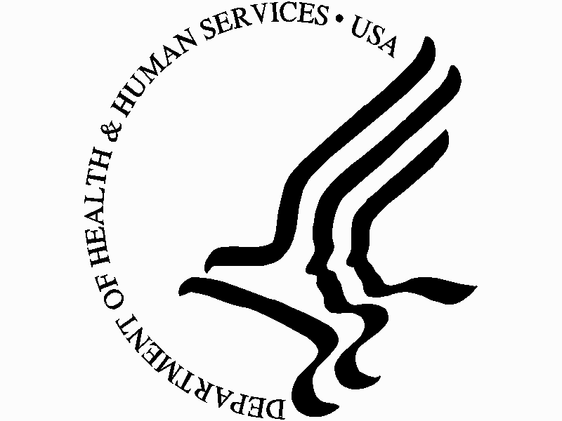
OIG NEWS

For Immediate Release Office of Inspector General
(202) 619-1343 Department of Health and Human Services
December 5, 2006 330 Independence Avenue SW.
Washington, DC 20201

OIG Reports More Than $38 Billion in Savings and
Recoveries for FY 2006

The Department of Health and Human Services (HHS) Office of Inspector General (OIG) Semiannual Report to Congress reported significant audit, evaluation,
and investigation accomplishments for the second half of fiscal year (FY) 2006
(April 1, 2006 – October 30, 2006). The report announced that OIG had achieved a record $38.2 billion in savings and expected recoveries for FY 2006.

Specifically, OIG’s $38.2 billion in savings and expected recoveries encompasses $35.8 billion in implemented recommendations and other actions to put funds to better use, $789.4 million in audit receivables, and $1.6 billion in investigative receivables.

“These savings and recoveries reflect our commitment to protect the financial integrity of the Department’s programs and ensure their efficient and effective operation,” said Inspector General Daniel R. Levinson. “We will continue to employ all of our audit, evaluation, investigation, and legal tools and collaborate with OIG’s government partners to accomplish this mission.”

In FY 2006, OIG reported the exclusions of 3,425 individuals and organizations for fraud or abuse of Federal health care programs and/or their beneficiaries; 472 criminal actions against individuals or organizations that engaged in crimes against HHS programs; and 272 civil actions, which include False Claims Act and unjust enrichment suits filed in district court, Civil Monetary Penalty settlements, and administrative recoveries related to provider self-disclosure matters.

Highlights of OIG accomplishments from the second half of FY 2006 include:

- Lincare Holdings, Inc., and its subsidiary Lincare, Inc. (collectively, Lincare) agreed to pay $10 million to resolve allegations that Lincare had paid illegal kickbacks and violated the Physician Self-Referral Law. OIG alleged that from January 1993 through December 2000, Lincare engaged in a nationwide scheme to pay physicians kickbacks to refer their patients to Lincare. The Lincare settlement represents OIG’s largest administrative settlement to date.
-MORE-

- AdvancePCS, a pharmacy benefits manager (PBM), agreed to pay the Government $137.5 million and enter into a 5-year corporate integrity agreement to resolve its liability for allegedly soliciting and receiving kickbacks from pharmaceutical manufacturers and paying kickbacks to potential customers to induce them to contract with the company. This settlement represents the first of its kind with a PBM.

- An OIG report recommended that CMS strengthen Federal certification standards for nursing home emergency plans. OIG’s study of emergency preparedness for selected nursing homes in five Gulf Coast States during the 2004 and 2005 hurricanes found that those facilities all experienced problems, whether evacuating or sheltering in place. Administrators and staff often did not follow their emergency plans, the plans were often missing suggested provisions, and a lack of collaboration between State and local emergency entities and nursing homes impeded emergency planning and response.

- OIG identified $87 million in Federal Medicaid overpayments for targeted case management services in Massachusetts. Medicaid pays for targeted case management services to assess Medicaid beneficiaries’ service needs, refer beneficiaries to needed services, and monitor the services. It does not pay for direct social services to which beneficiaries have been referred. However, the State included the costs for direct social services in the rates used to claim reimbursement for targeted case management services. OIG recommended that the State refund the resulting $87 million overpayment.

- OIG issued final regulations that establish two new safe harbors under the Federal anti-kickback statute for arrangements involving the donation of certain electronic health information technology and services. The final rule seeks to lower perceived barriers to the adoption of health information technology by finalizing safe harbors that promote the adoption of electronic prescribing technology and open, interconnected, interoperable electronic health record systems, while safeguarding Federal programs and beneficiaries
against undue risks of fraud and abuse.

To read more about OIG’s activities and see the full text of the Semiannual Report, go to: (link to be inserted)
####

